CORPORATE FINANCE PREREQUISITES
FORMULA SHEET
Metric / concept | Formula
Current ratio | Current Assets / Current Liabilities
Quick ratio | (Cash + Receivables) / Current Liabilities
Debt / Equity | Financial Debt / Equity
Interest coverage | EBIT / Interest Expense
Net margin | Net Income / Revenue
ROA | Net Income / Average Total Assets
ROE | Net Income / Average Equity
Asset turnover | Revenue / Average Total Assets
Future Value | FV = PV × (1 + r)^n
Present Value | PV = FV / (1 + r)^n
Bond value | PV of coupons + PV of face value
Gordon Growth | P0 = D1 / (r − g)
NPV | PV of future project cash flows − initial investment
IRR | Discount rate that makes NPV = 0

EXERCISE 1 · Quick diagnostic
Orion Retail reports the following simplified information for the year (EUR m):
Item | Amount
Revenue | 200
Net income | 8
EBIT | 18
Interest expense | 6
Current assets | 54
of which inventory | 32
Current liabilities | 36
Financial debt | 60
Equity | 40
Total assets | 100
1. Calculate: Current Ratio, Quick Ratio, Debt/Equity, Interest Coverage, Net Margin, ROA and ROE.
2. Which ratio looks strongest? Which one worries you most?
3. The Current Ratio looks acceptable at first sight. Assess the quality of Orion's liquidity position.
4. You are the CFO. Identify ONE priority you would investigate before requesting a new bank loan.
Decision rule
Do not stop at “good” or “bad”. Explain the economic reason behind the ratio.

EXERCISE 2 · Credit Committee vs Equity Investor
Atlas and Bolt operate in the same industrial-services sector. Their simplified 2025 figures are below (EUR m).
Item | Atlas | Bolt
Revenue | 300 | 300
Net income | 18 | 21
EBIT | 30 | 42
Interest expense | 5 | 12
Current assets | 90 | 75
Inventory | 20 | 40
Current liabilities | 45 | 60
Financial debt | 50 | 120
Equity | 100 | 60
Total assets | 180 | 210
1. For each company, calculate: Current Ratio, Quick Ratio, Debt/Equity, Interest Coverage, Net Margin, ROA, ROE and Asset Turnover.
2. Which company is more profitable? Be precise: your answer may depend on the profitability metric used.
3. Which company has the stronger credit profile? Give at least THREE reasons.
4. You are a bank considering a EUR 20m five-year loan. Which company would you finance?
5. You are now an equity investor seeking high return and willing to accept more risk. Would your answer necessarily be the same? Explain.
6. Bolt has the higher ROE. Why could that ratio be misleading if looked at alone?

EXERCISE 3
You are a financial analyst reviewing the three-year evolution of Nova Components, a company supplying the automotive industry.
Management highlights strong growth and improving shareholder returns before meeting with potential lenders and investors. Your objective is to assess whether the company has actually become financially stronger.
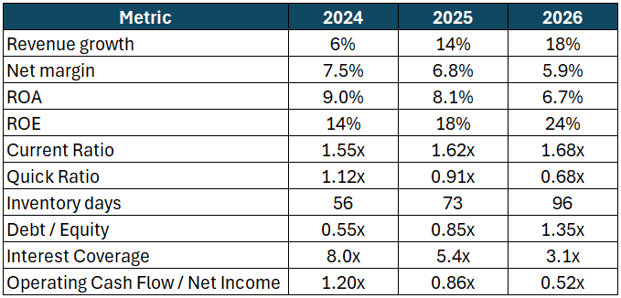
1. Prepare a short financial diagnosis of Nova Components. Do not comment on every indicator. Identify the main messages emerging from the financial evolution.
2. Select the three indicators you consider the most relevant to assess whether Nova Components has improved its financial situation.
3. Identify one apparent contradiction in Nova Components' financial profile.
Explain what could explain this situation.
4. Management states:
"The company is financially stronger in 2026 because revenue growth accelerated and ROE increased from 14% to 24%." Do you agree with this statement? Explain.
5. Would a lender and an equity investor necessarily reach the same conclusion about Nova Components? Explain your reasoning.
6. Before making an investment or financing decision, what additional information would you request?
7. You have five minutes with the CFO. Provide your final recommendation in no more than four sentences.

